


The 4-H Newsletter






Calendar of Events

MARCH
4: 4-H U Info Meeting
6-8: JLC
10: Food Challenge
11: Jr. Leader Meeting
20: Safety Poster & Slogans Due
22-Apr 1: Southern Regional Shooting Sports Matches
23: Spring Cookery Drop-off
26: Sewing Club
27: Records and Portfolios Due

APRIL
1: Jr. Leader Mtg
8: Lego STEM Camp
10-18: State Shooting Sports Competition
15: Ag Day
16: Achievement Day & Upcycled Contest
18: Parish Clean Up Day
22: 4-H University Registration & Deposit Due
23: Sewing Club

MAY
1: Leadership Board Apps. Due
7: Jr. Leader Mtg
8: 4-H U Final Payment Due
12: Southeast Region Culinary Arts Contest
22: LOST Camp Registration & Deposit Due
29: 4-H U Contest Training

St. James Parish March 2026



Beef, Seafood & Egg Spring Cookery
EGG: The prepared dish must utilize a minimum of 4 eggs, this can be 4 whites, 4 yolks, or 4 whole eggs. The divisions are:
1. Appetizer/Side Dish 2. Main Dish/Salads 3. Dessert
BEEF: 4-H’ers must prepare a dish which contains a minimum of one pound of beef.
The divisions are:
- Ground Beef 2. Other Beef Cuts
SEAFOOD: 4-H’ers must prepare a dish that contains a minimum 1 cup of seafood. The Seafood must be fresh, frozen, pasteurized, or dried. The divisions are:
- Crab 2. Crawfish 3. Shrimp 4. Other Louisiana Seafood (Must be listed on the Louisiana Seafood List – found in separate packet)

Monday, March 23rd, 2026
Dish Drop-off: 7:30am-6:00pm
All dishes will be judged on Tuesday, March 24th and winners will
be announced on our Facebook page.

Contest Rules
All rules will be strictly enforced. If you have a question, call the 4-H Office before preparing a dish.
- The contestant must be a 4-H member, all division are open to any age.
- All dishes must be prepared following all food safety guidelines from the USDA and can be found at www.FoodSafety.com.
- A contestant may enter as many dishes as they wish but can only enter one dish per division.
- Winning recipes may not be repeated in subsequent years by the same contestant.
- Contestants may only use one recipe/category.
  - Example: A contestant may not enter a jambalaya recipe in poultry and again in rice.
- The dish needs to be in a disposable plastic container, with a hard lid, with only 1 to 2 servings inside. (Dish Presentation is not a concern for the parish contest)
- There are to be NO raw eggs in the final product.
- Entries must meet all division requirements.
- One TYPED recipe must accompany the dishes.
  - Recipes will be scored according to the Recipe Evaluation below.
- All dishes must be brought to the contest completely chilled in an ice chest on ice. Judges will heat up dishes if needed.

END OF THE YEAR AWARD OPPORTUNITIES
4-H Golden Clover Award 4-H Emerald Achievement Award
-Students 14 and under -15 years of age (or older)
-Must have at least 2 years of 4-H club work. -Must have 3 years of 4-H club work.
*Contact 4-H office for Application* -Must have completed one year of active Junior Leadership work.
*Contact 4-H office for Application*

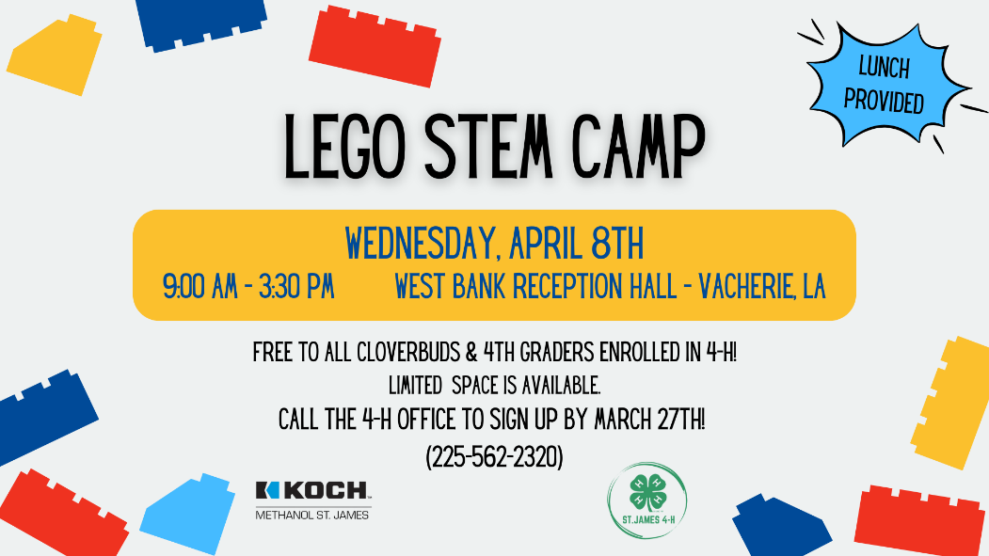

Up-Cycled Contest
At Achievement Day – April 16th
Create a decorative or usable item made from things that would have otherwise been given away, thrown away, or recycled. Definition of Upcycle: reuse (discarded objects or materials) in such a way to create a product of a higher quality or value than the original.
St. James Parish 4-H Achievement Day
Thursday, April 16th
9:00am || Lutcher High School
An end of the year celebration for all 4-H Cloverbud clubs and 4-H Clubs!

Song & Yell Contest | Club Awards | Activities & More

Contest Rules:
-Entries must be safe, sturdy, have no rough edges, and be free from inappropriate content. Consider entries from the upcycled fashionable items, home décor, tools, recyclable plastic, et. Possibilities are endless.
-Each entry may be no longer than 2ft x 2ft.
-Judges will look for originality, creative use of materials, presentations, and conservation message.
-Look to recycling bins and yard sales for inspiration.
-Include your name, grade, school on the bottom or back of your entry. Group or individual entries are acceptable.
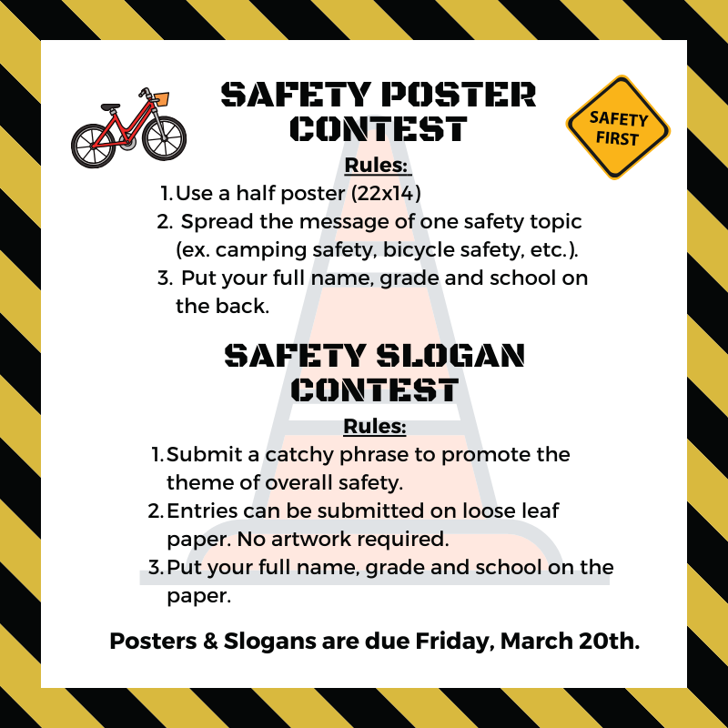
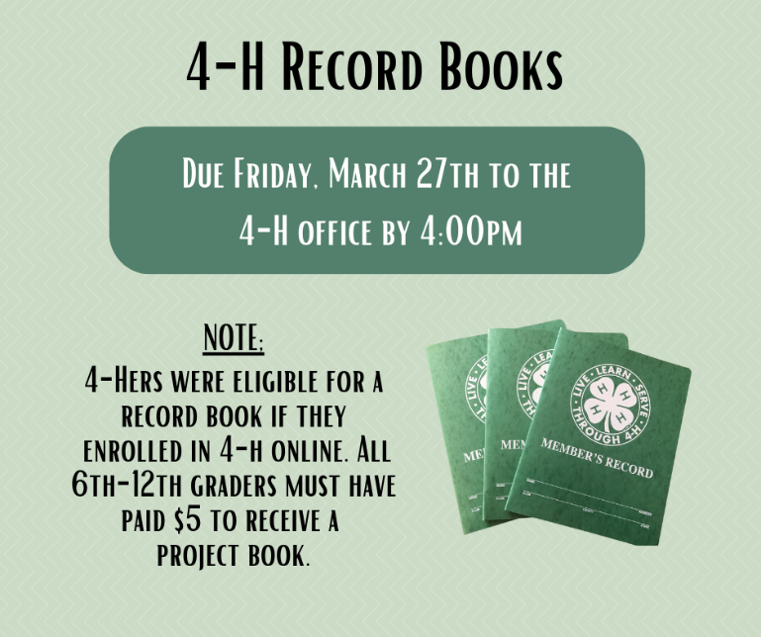
-Entries must be brought to achievement Day for judging and display. The contest is open to all 4-H members (3rd-12th grade)



Welcome 4-Hers!
Carly B. Dufresne Laynie A. Smith
Associate Extension Agent Associate Extension Agent
cmboudreaux@agcenter.lsu.edu larceneaux@agcenter.lsu.edu

2204 S. Albert Street
Lutcher, LA 70071
(225) 562-2320

ADA: If you need a special accommodation for your participation in the event, please contact the office at 225-562-2320 at least two weeks prior to the event.
EEO: The LSU AgCenter is a statewide campus of the LSU System and provides equal opportunities in programs and employment.



